# [Flora/fauna choices]

# **Choices are:** Red tailed hawk, Snowshoe hare, Western

# **Predator:** Red tailed hawk

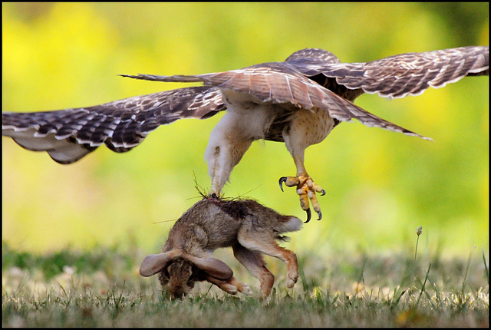

**Foods:**

Frequent victims include voles, mice, wood rats, rabbits, snowshoe hares, jackrabbits, and ground squirrels.

**Feeding Cycle:**

Year round, no real hibernation.

**Hunting Area:**

Estimate about 50 miles area of hunting ground.

**Behavior:**

Red-tailed Hawks are large, sharp-taloned birds that can be aggressive when defending nests or territories. They frequently chase off other hawks, eagles, and Great Horned Owls. Courting birds fly with legs hanging beneath them, or chase and swoop after each other, sometimes locking talons. Mated pairs typically stay together until one of the pair dies.

**Habitat:**

Red-tailed Hawks occupy just about every type of open habitat on the continent. This includes desert, scrublands, grasslands, roadsides, fields and pastures, parks, broken woodland.

### **Nesting:**

Red-tailed Hawks typically put their nests in the crowns of tall trees where they have a commanding view of the landscape. They may also nest on a cliff ledge or on artificial structures such as window ledges and billboard platforms.

## **Prey:** Snowshoe hare

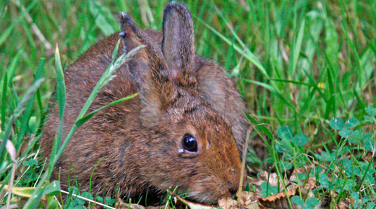

**Description:**

Unlike most snowshoe hares, the fur of those that inhabit the coast of Washington and Oregon do not change white in the winter. Snowshoe hares can be identified by their large hind feet and the black ear tips.

### **Foods:**

These adaptive mammals use sharp front teeth to clip and eat a wide variety of grasses, forbs and shrubs, including willow and alder bark, buds and small branches. Snowshoe hares will even eat carrion.

**Grazing Area:** Estimate 10 miles.

### **Behavior:**

Snowshoe hares are nocturnal, so they're more likely to be seen at dawn and dusk. These animals have acute hearing and are able to detect predators.

When alarmed they will hide in dense brush, under logs or within the burrows of other animals. Sometimes snowshoe hares will thump their hind feet on the ground in warning

### **Habitat:**

Snowshoe hares live in the coniferous and boreal forests of the Rocky Mountains, the Appalachian Mountains, the Pacific Northwest, New England, Alaska, Minnesota, Michigan, and Montana. Within the United States, most of these coniferous forests are found on mountaintops, such as the Rockies, or near the Canadian border.

**Nesting:**

Snowshoe hares are forest-dwellers that prefer the thick cover of brushy undergrowth.

# Tree: Western Red Cedar

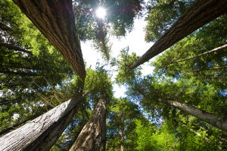

**Description:**

The Western Red Cedar is very commonly found in the wild in the northwestern United States and Canada. In cultivation, it can be effectively used as a hedge or screen. Foliage is glossy, green and scale-like and is aromatic. The bark is reddish brown and sheds. Foliage may turn brownish bronze in winter. Can be grown close to buildings and in open spaces, it can be an excellent skyline tree.

Foliage: Needled Evergreen  
Height: 50-60 feet (130-200 feet in the wild)  
Spread: 15-20 feet  
Shape: Pyramidal  
Growth Characteristics: Slow-growing

# Shrub/grass:

**Bluebunch Wheatgrass:**

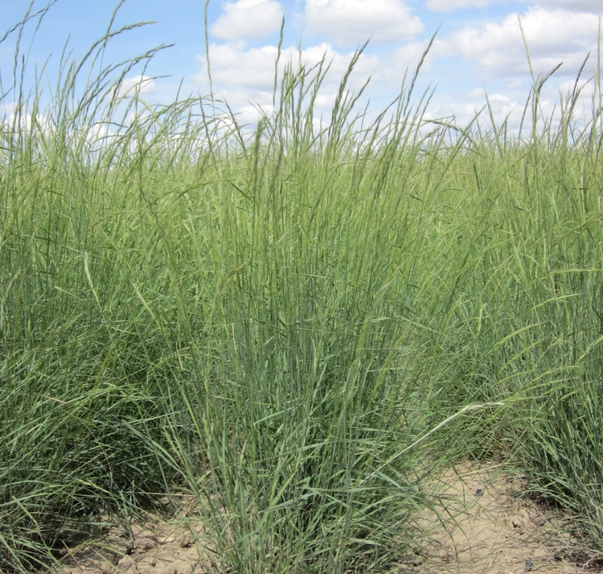

**Description:**

Bluebunch Wheatgrass is a perennial bunchgrass common to the northern Great Plains and the Intermountain regions of the western United States. It is a long-lived cool season native grass with an extensive root system with strong tillers. Bluebunch wheatgrass spreads by seed, except in high rainfall zones where some short rhizomes may occur. Bluebunch wheatgrass is highly variable and grows to 1.5 to 4 feet tall and seed spikes are 3 to 8 inches long. The auricles (ear-shaped appendages where leaf blade and sheath meet) are pointed and semiclasping to nearly lacking. Leaves are lax, flat to inrolled, 4-6 mm wide and green to blue in color. Leaf sheaths are generally smooth and hairless.

**Big SageBrush:**

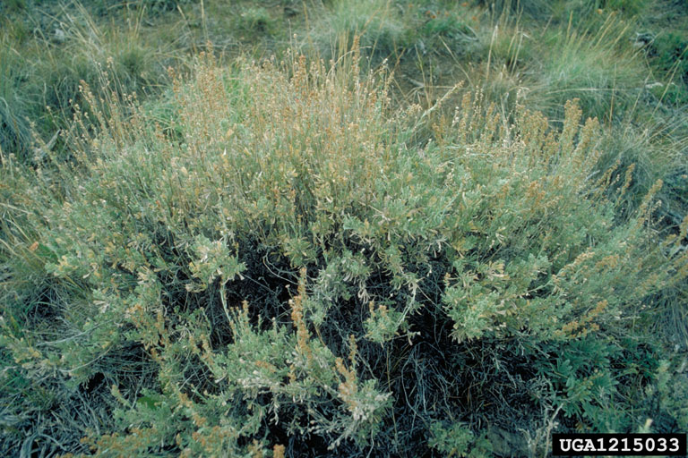

**Description:**

Big sagebrush and its subspecies, are tall, rounded, U.S. native shrubs with short branched, woody trunks. The height is normally about 4 feet, but varies from 2 feet in arid conditions to as high as 15 feet on favorable sites. The winter persistent leaves are wedge to fan-shaped and are usually three-lobed at tips. They are strongly aromatic. Buds form about June with flowering and seed formation in the fall.

Source:

https://www.fws.gov/refuge/Willapa/wildlife_and_habitat/

Animal Diversity Web, University of Michigan Museum of Zoology

https://plants.usda.gov/core/profile?symbol=pssp6